**The Pageant Weevil**

**URL:** [http://blackcrownproject.com/miasma/strata/bestiary/curculionoidea/pageantweevil](http://blackcrownproject.com/miasma/bestiary/curculionoidea/pageantweevil)

**Infobox -** The infobox for this object is as follows:

**Withdrawn by:** [Access Code]

**Name:** The Pageant Weevil

**Myiasis:** ‘’’’...’’’’..’’’.’’’.’.’

**Eremite:** ____The Miasma Eremite____

**Notes:** ____Clerk!____ Do not touch under any circumstances. Specimen is reported by Eremite as extremely toxic. Any requests for handling privileges will be met with instant refusal. We have noted that the severing of the forward right appendage was conducted *in situ*, and should not be reported as specimen neglect.

**Story Context**

The weevil is a specimen that the Eremite took from the town to illustrate the strange practice that the townspeople have towards these insects. They find their nests and throw paint over them, and then very carefully paint them in bright colours and cut some of the legs off to stop them walking into the town, as they are reputedly very poisonous. There is a text object in which the Eremite describes picking up a weevil that is about to bite Death Of A Friend. However, that weevil was not painted, and this one is. This begs the question of how this occurred.

Currently, this is a viewpoint object. Perhaps in Phase 2 or 3 we can return to it and the players will be able to use an item on it, but at the moment it is to lend weight to the story.

This object is not reached directly from the Storynexus content, but rather through clues hidden there as to how the Miasma content is organised.

**Crunch Description**

## Views - The views below show the Weevil from 4 different angles, plus two close ups, one of the head and one of the pulled-off, right front leg. (NB: These are all knocked up by us and do not in anyway represent final artwork). The view is ‘rotated’ by tapping on the left/right of the Weevil. The close ups are activated when the appropriate area is tapped. Once in close up, tapping anywhere will revert back to the normal view.

**View Background** - The objects are floating in space as if held by invisible hands. The light source is always from the position of the viewer as if they are wearing illuminating devices affixed to their glasses. The background for the items will be a slightly torn, roughed parchment, identical or very similar to the final backdrop in the story engine.

**Options -** The comment options will disappear when a closeup is activated (along with the infobox?) and reappear when the players tap back out.

**Access Codes -** As there is no extant “solutions” to this object, but it is not linked from the story, I think that the access code should be in the infobox (see above).

**If player is logged in -** The access code link text says - [Player Name] - \\_\Clerk!/__/ Withdraw for future inspection?

**If user is not logged in/does not have an account -** The access code link text says - Withdraw for future inspection?

In both cases, the access code gives the player a quality named “The Pageant Weevil” with a value of 1.

## Model

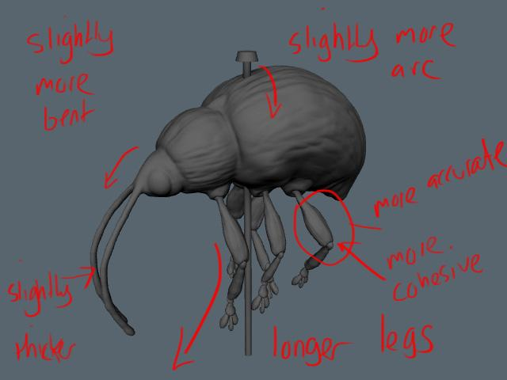

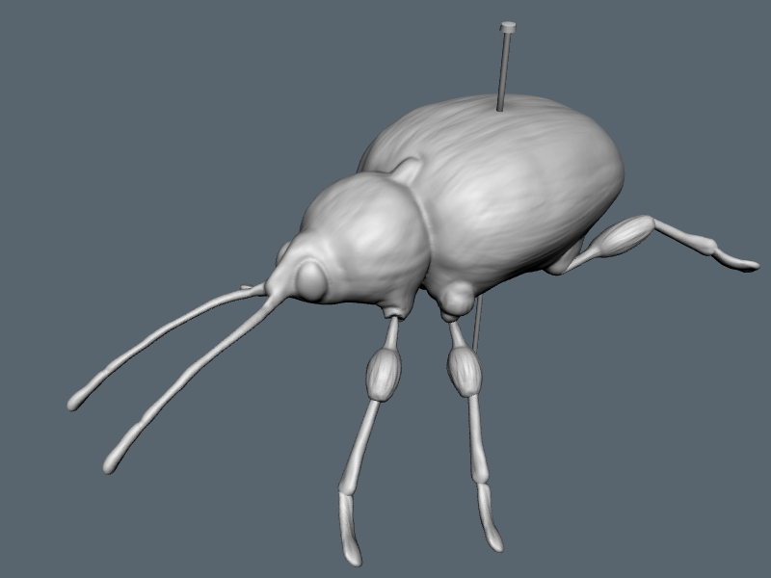

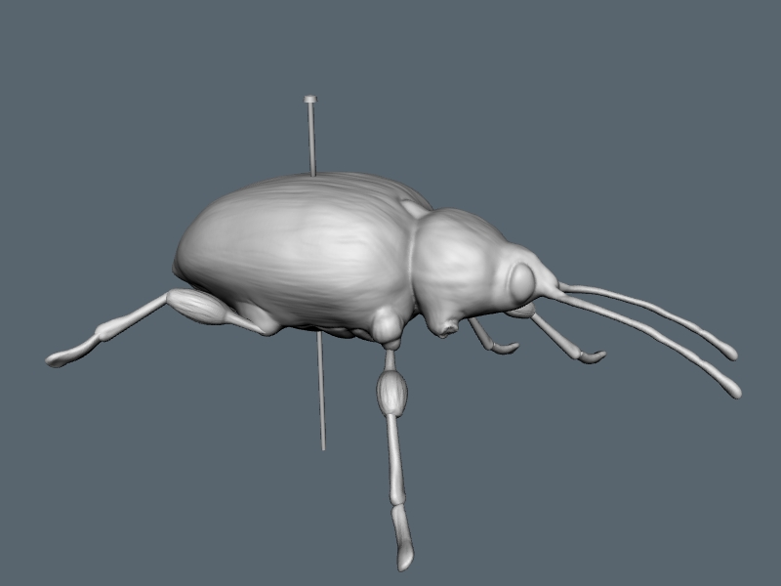

## 

## 

## Views

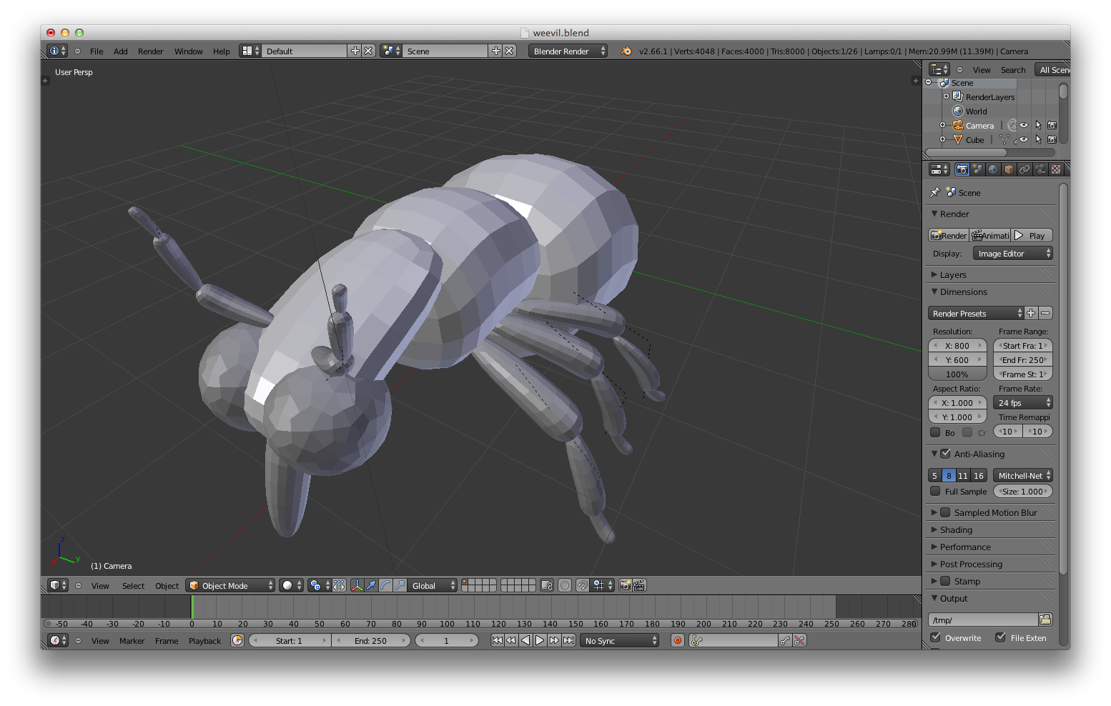

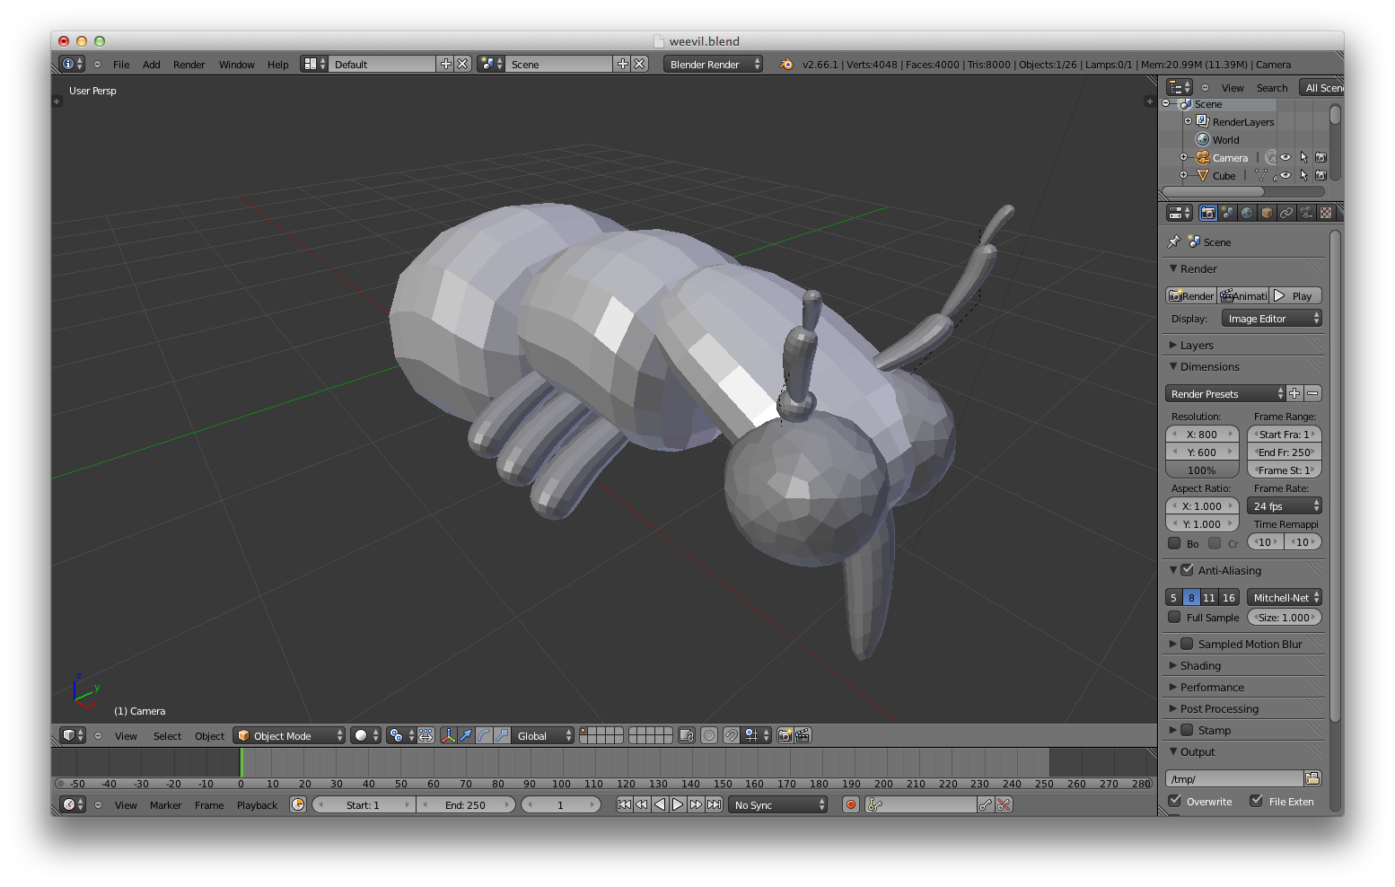

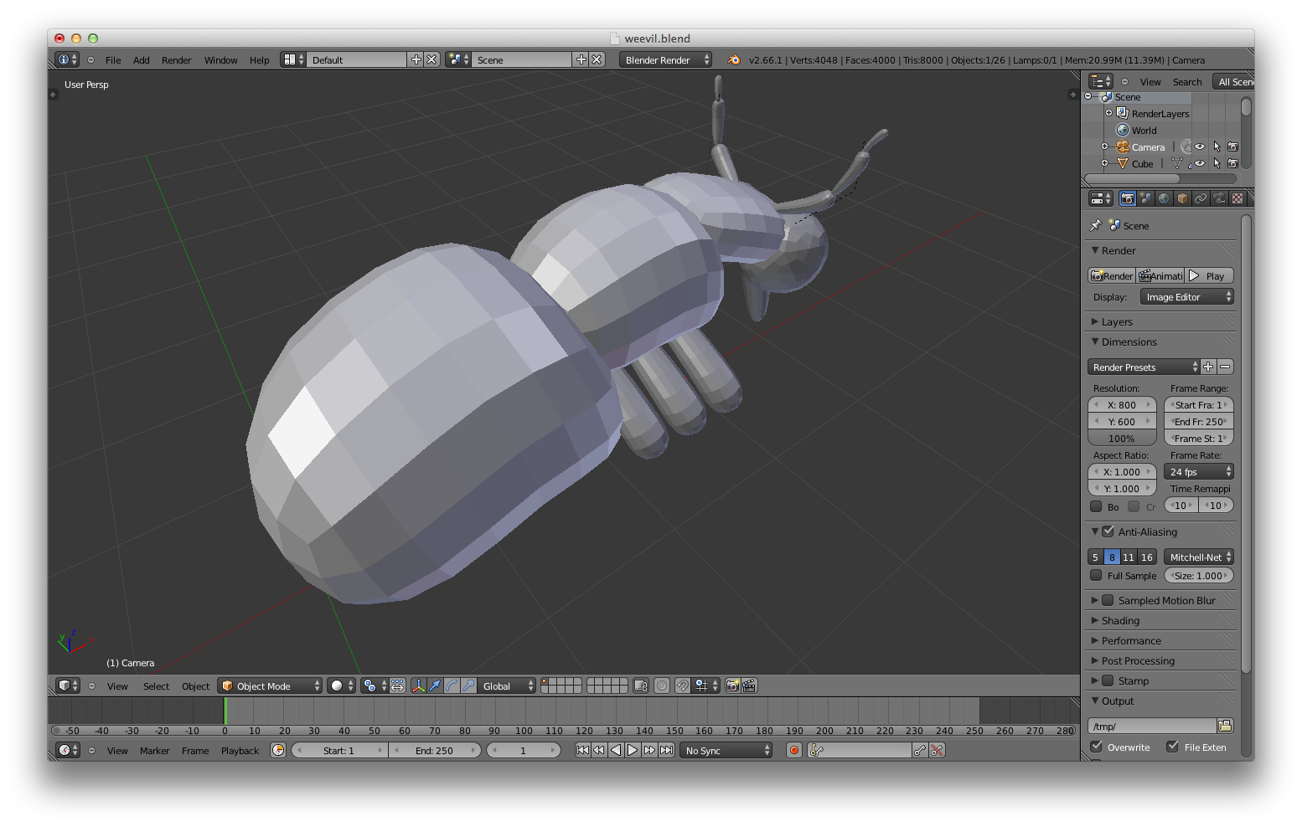

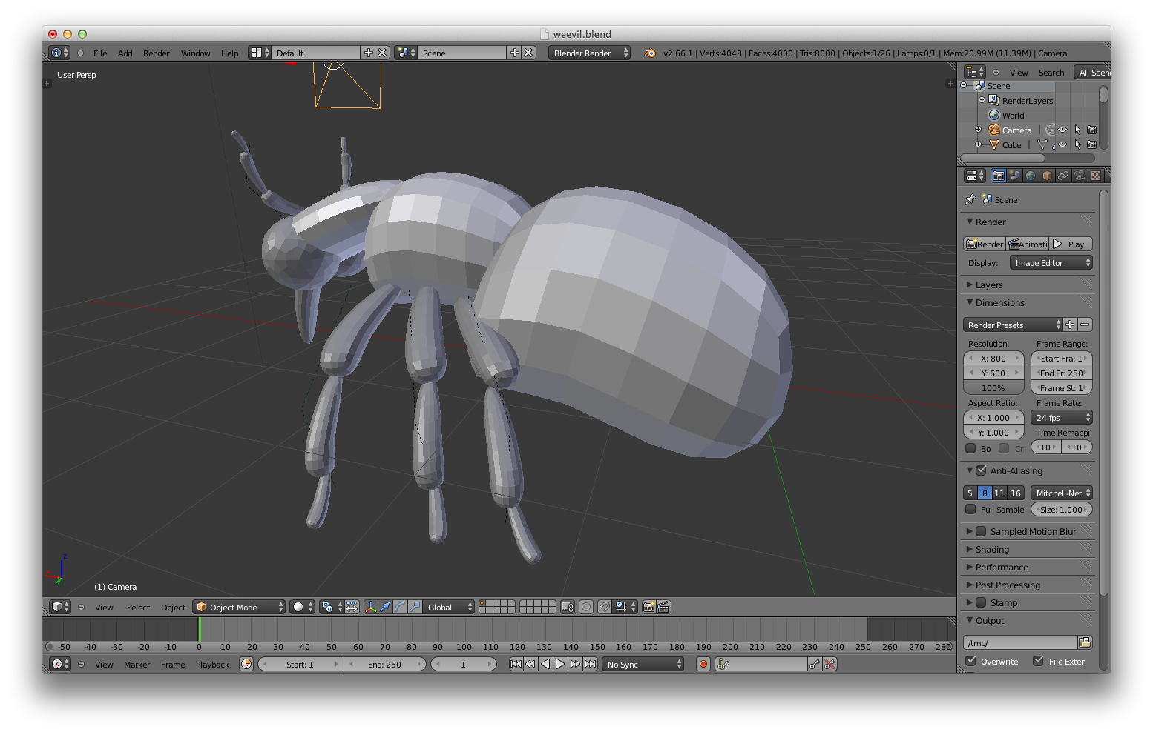

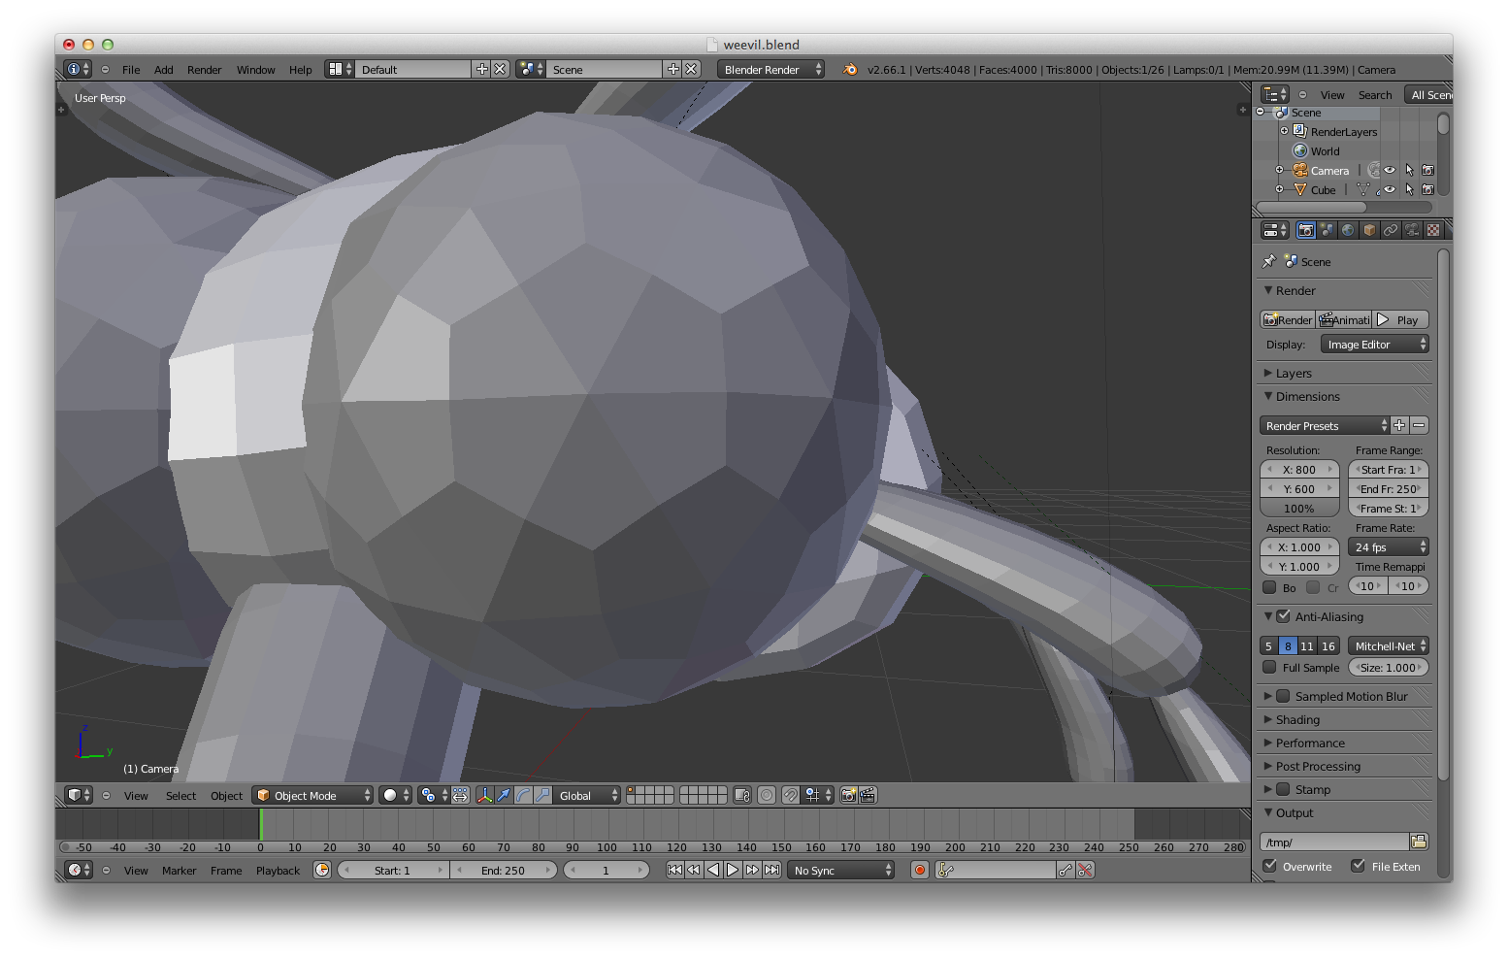

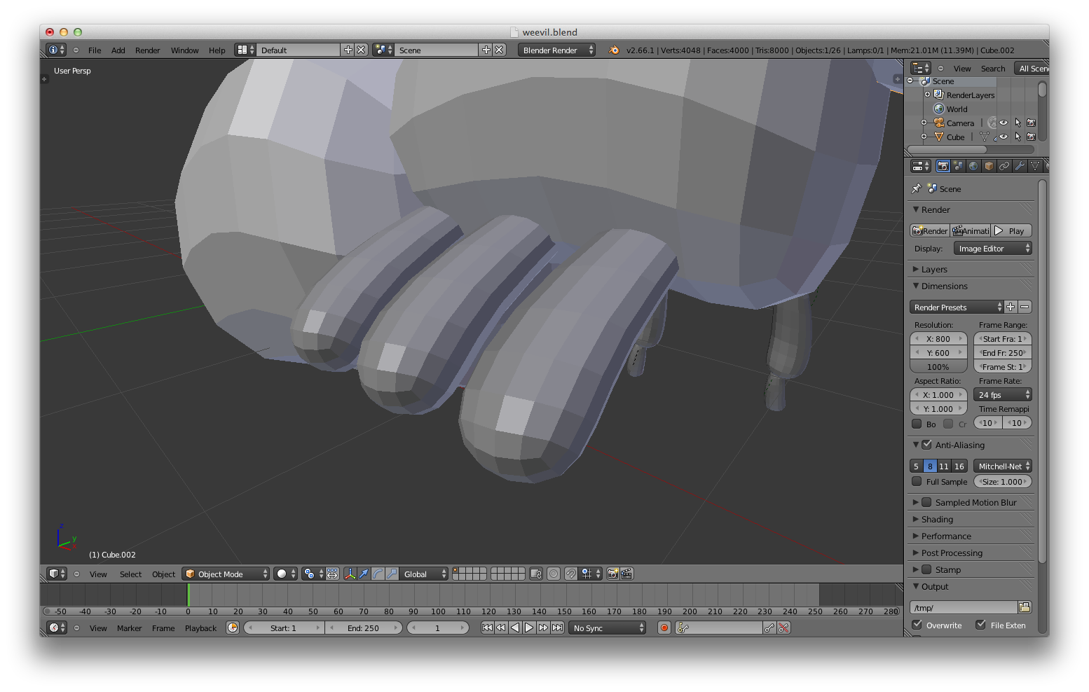

**Fluff Description**

The pageant weevil is, unsurprisingly, a weevil. It is dead, fairly dry, and is held in place with a large pin through its back. It is displayed the right way up, with its back pointing “up”.

It very closely resembles *Curculio Elephas* (see below) in shape and features, with a few differences:

- It has a light fur over its back and legs.

- It has not one but two probisci, with one antenna on the outside edge of each respectively.

- Its actual exoskeleton is patterned in a rather dark, unpleasant pattern, giving the impression of oil or muddy water, as well as long lines which resemble pine needles. This all looks like very natural colouring however, a sort of camouflage.

- The front right leg of the weevil has been cut off, or rather pulled off - some small viscera can be seen dried and curled where the rather savage force was applied.

- When the head is zoomed into, between the eyes is a small rostrum

- Painted over its back and down onto its legs, in a rather haphazard hand, is a pattern in thick paint (akin to oil or acrylic, I would think). The pattern is below, but obviously it needs to look a little more “painted on” than this does. The yellow in that pattern should have the sheen of gold, if possible - The whole thing has the aesthetic appearance of illuminated art from medieval manuscripts; The Book of Kells, that sort of thing. This is just a form and colour guide - stylisation and artistic licence are encouraged from my end!

- There is a pin stuck through its back.

**Reference**

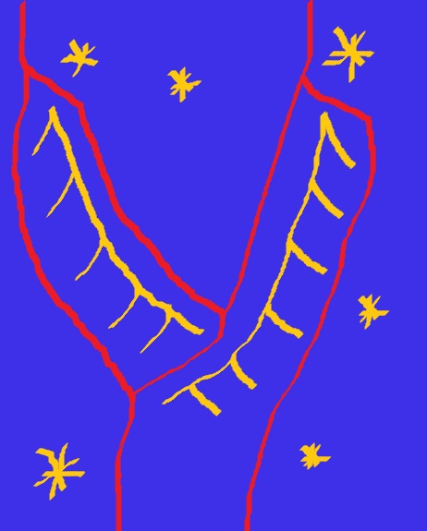

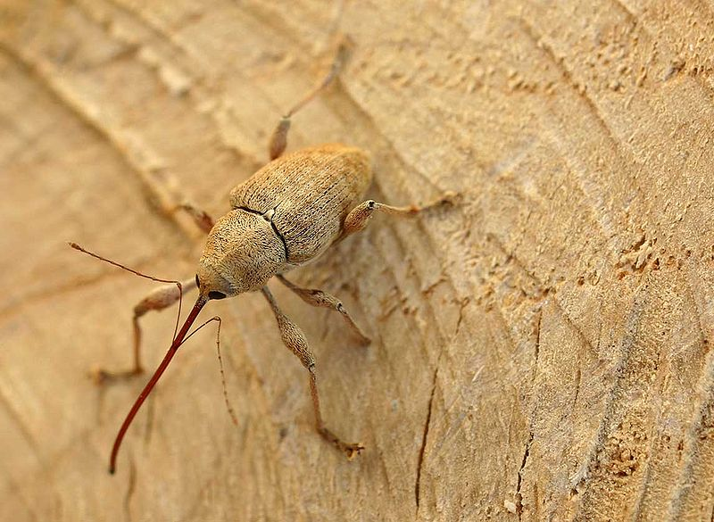

This is *Curculio Elephas*, which the Weevil resembles, apart from the fact that it has two of these long snouts.

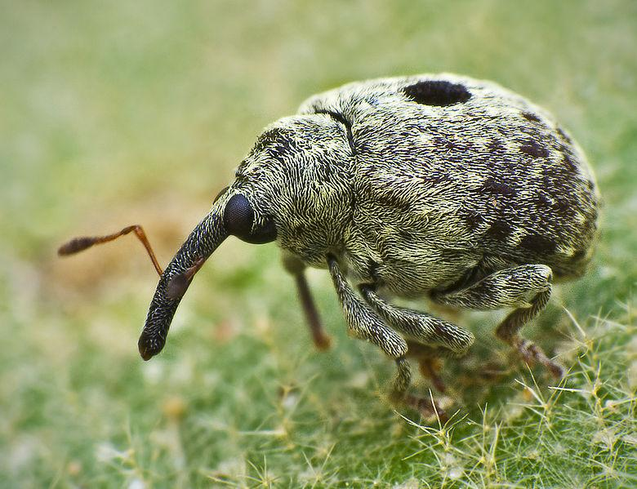

I like the furriness of this.

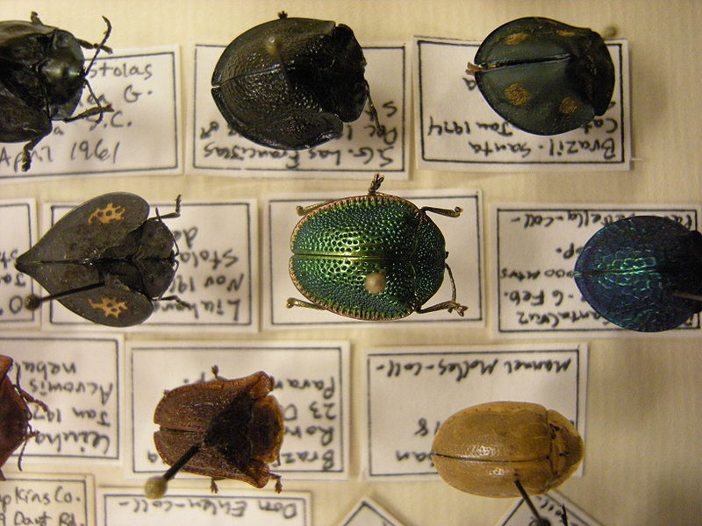

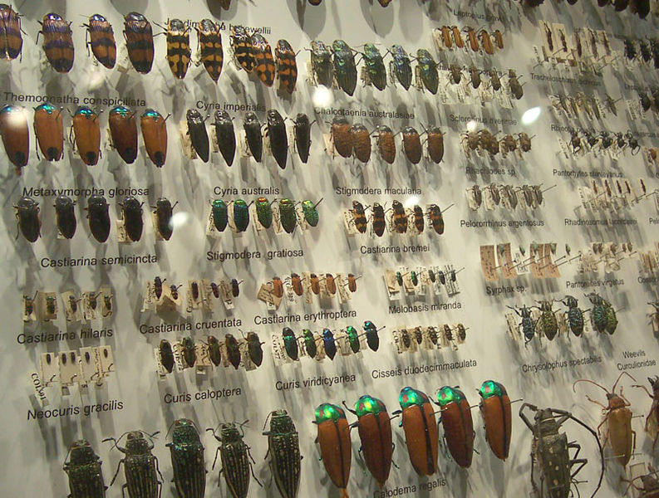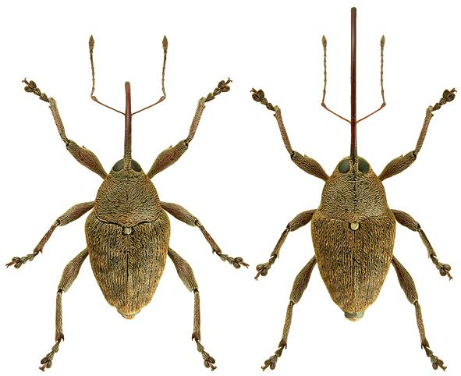

**Texture Reference**

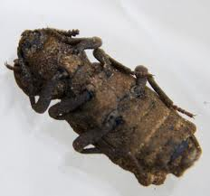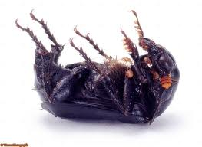

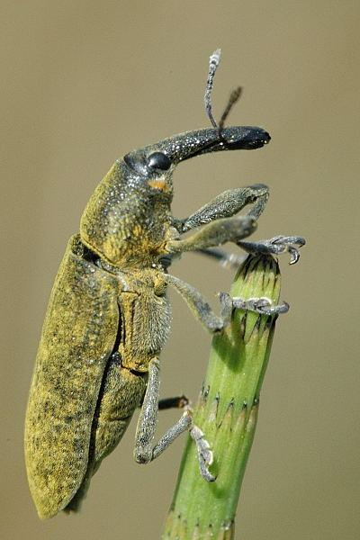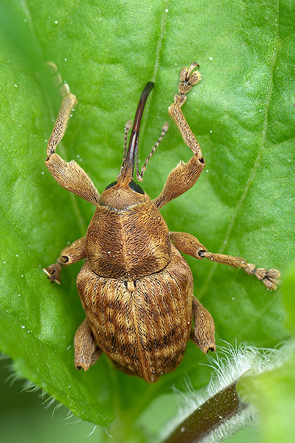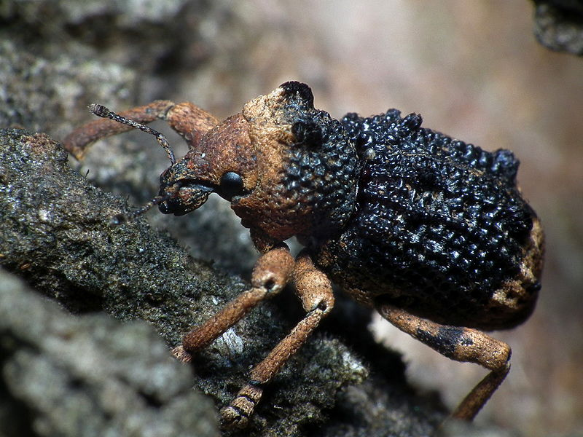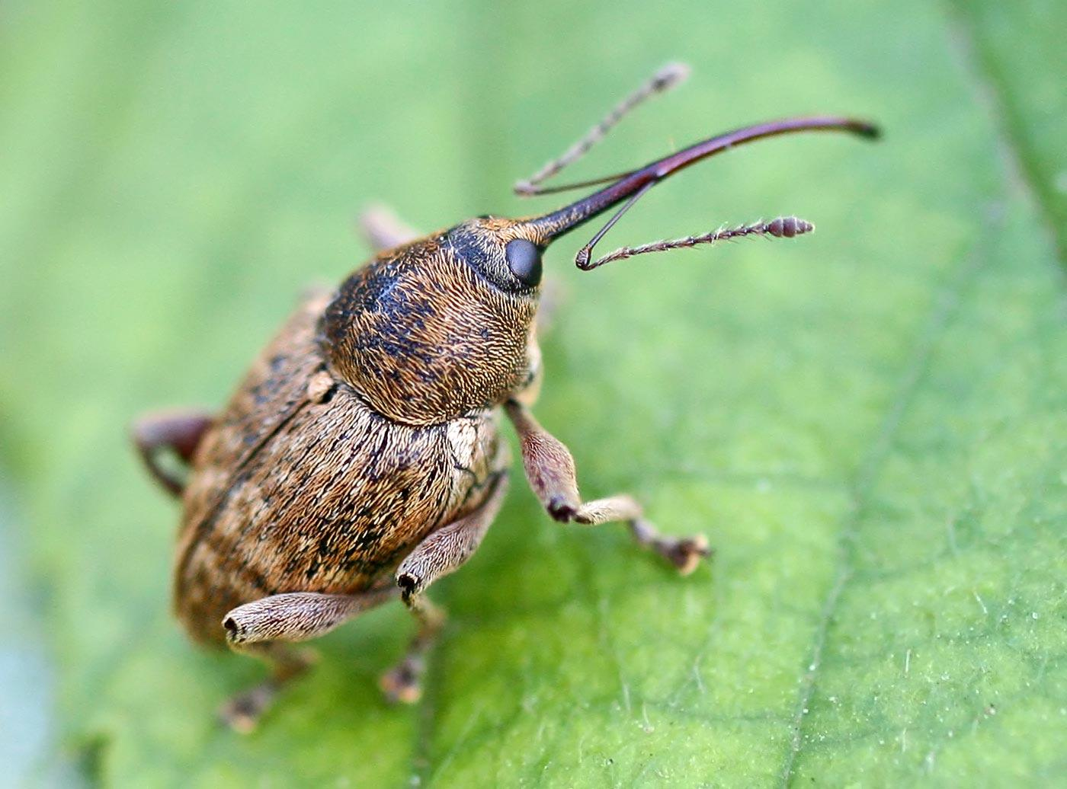

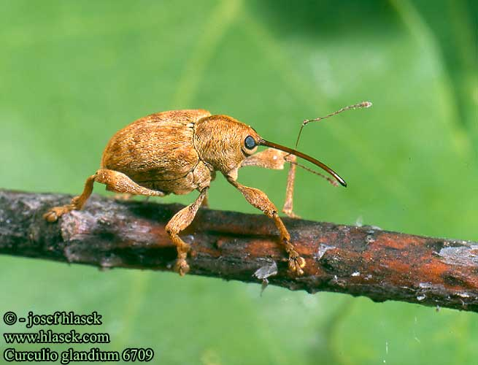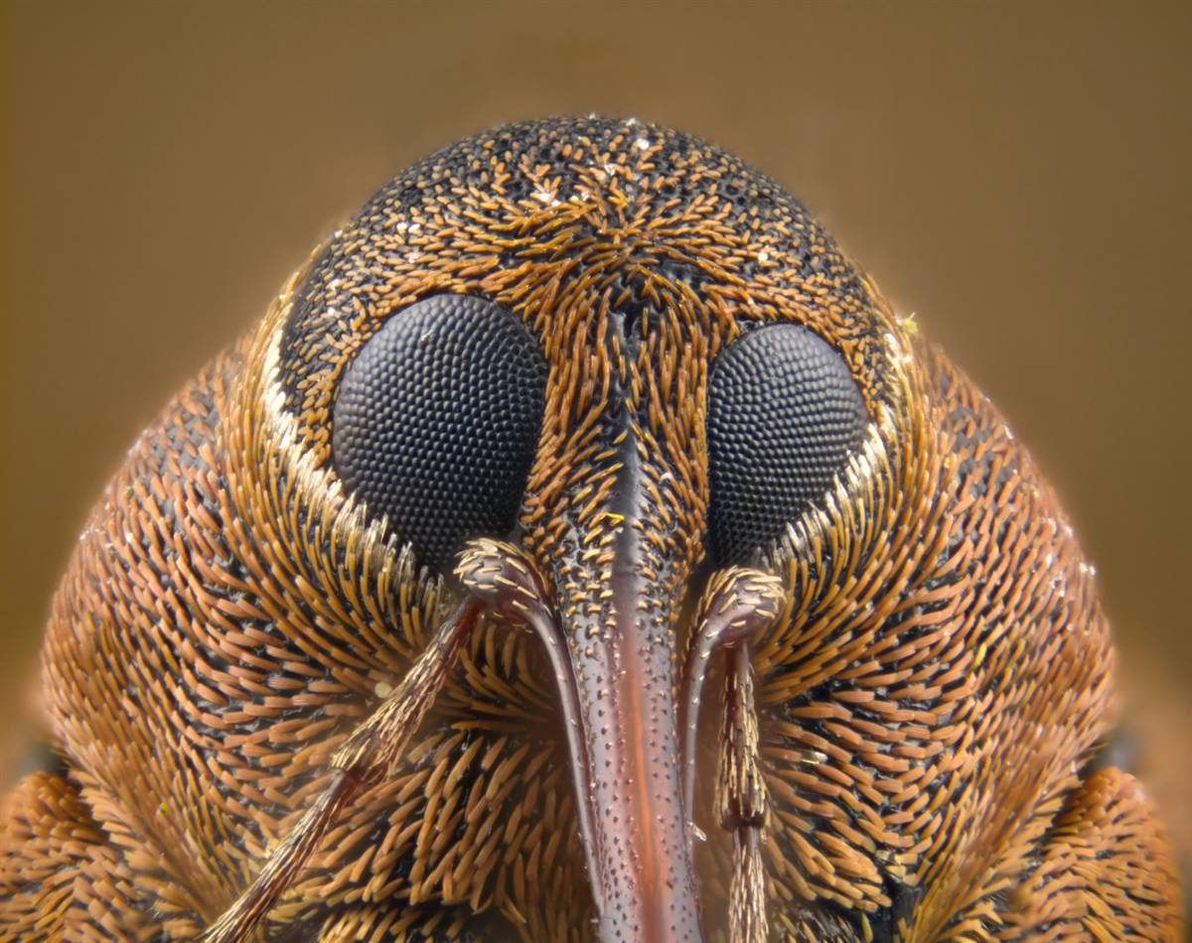

## Mood boards

